Habitat Impact Assessment

2018

AUCHLYNE & SUIE ESTATE

Colin Wells

August 2018

1. INTRODUCTION

Habitat Impact Assessment was carried out at Auchlyne & Suie Estate during 26th June– 4th July 2018 using protocols based on 'Best Practice' methodology designed by SNH for deer managers (Bestpracticeguides.org.uk. 2018), with additions prescribed in the Innishewan Farms Upland Habitat Impact Assessment Plan for Deer Management (Colquhoun 2018, Appendix 6).

Impact assessment was carried out on dwarf-shrub heath and blanket bog habitats within Auchlyne and Bovain management units and dwarf-shrub heath within Suie management unit.

2. METHODS

Habitat Impact Assessment

Herbivore impact information was collected for the following features: blanket bog and dwarf-shrub heath. These were selected as representative of the range of habitats within the estate.

Table 1: Summary of habitats surveyed within the survey area.

BPG Assessment Class | Natura habitats included | NVC types covered
Blanket bog | - blanket bog | M1-3, M17-19
Dwarf-shrub heath | - EU dry heath, Northern Atlantic wet heath | H10, H12, H18, H21, M15

SNH provided random generated waypoints for each of the features to be monitored, spread across the site. From these, 90 points were surveyed, 60 on Dwarf-shrub heath and 30 on Blanket bog. The geographical distribution of sample plots was partly constrained by agricultural management units across the estate (Table 2).

Table 2: Types of habitat plots surveyed across the estate.

Agricultural Management Area |  | DSH plots |  | BB plots
Bovain | 1301 ha | 10 |  | 0
Innishewan | 1695 ha | 20 |  | 30
Suie | 1690 ha | 30 |  | 0

30 of these waypoints had been previously assessed in a preliminary smaller-scale survey and these were revisited and reassessed and incorporated into an expanded sampling network of 90 plots.

(N.b. Three of the dry shrub heath plots from this first survey cycle within the Auchlyne management unit were found to have been accidentally placed on blanket bog; these were therefore reassigned to the latter habitat and assessed accordingly during the current monitoring cycle.)

Each randomly-selected assessment waypoint was located using a hand-held GPS receiver (Garmin GPSMap 64). Wherever the exact position of the waypoint did not represent the required habitat, the nearest location to the original point which contained the target habitat was selected and the waypoint grid reference adjusted accordingly.

Each assessment plot was marked at with a wooden post , and a 2 x 2 m quadrat set out, sub-divided into 16 smaller squares and aligned north from the selected grid reference. The marker post was always placed on the south-eastern corner of the plot. (Where posts were found to be missing from extant plots these were replaced). The tops of the marker posts were painted white to aid relocation.

Two photographs were taken of each assessment plot; one showing it in detail and a context picture to aid relocation. Both photographs were taken looking north.

For each habitat type, the relevant assessment of current impacts was made following ‘Best Practice Guidance’ (along with some additions contained within the Innishewan Farm Management Plan). These use a range of indicators provided and class each on a range from Low to High impact. Assessment of long-term impacts will be done by comparison with future years.

The indicators for each habitat type were grouped according to whether they represented impacts from browsing/grazing, trampling or dung and an overall assessment for each impact type made for each habitat. Browsing/grazing impact indicators included evidence of heather off-take, and trampling indicators included hoof-prints in bare-peat and Sphagnum moss (blanket bog) and stem breakage (dwarf-shrub heath).

In addition, a number of quantitative measurements were collected including: vegetation height, heather height, cover of bare peat and bog moss (blanket bog) and cover of heather (dwarf-shrub heath). This provided additional detail that may be useful in future comparisons.

Other observations made at each plot included: evidence for sheep, signs of recent burning, sign of old burning, vehicle tracks <10 m, presence of waterbody or course < 10 m.

Maps to show the distribution of impact results are shown in the report and collated in Appendix 2.

Summary tables of all the overall assessments for grazing, trampling, dunging, trend indicators are given in Appendix 3.

Photos of each plot are in Appendix 4 (contained on DVD).

All vascular species nomenclature follows Stace, (1997) and NVC classifications according to Rodwell (1991, 1992).

3. RESULTS

The following tables (3-5) summarise the results, presented in full in Appendix 1.

Table 3 - Browsing data by plot

Browsing impact | Dwarf shrub heath | Blanket bog
Low | 52 | 29
Moderate | 3 | 1
High | 5

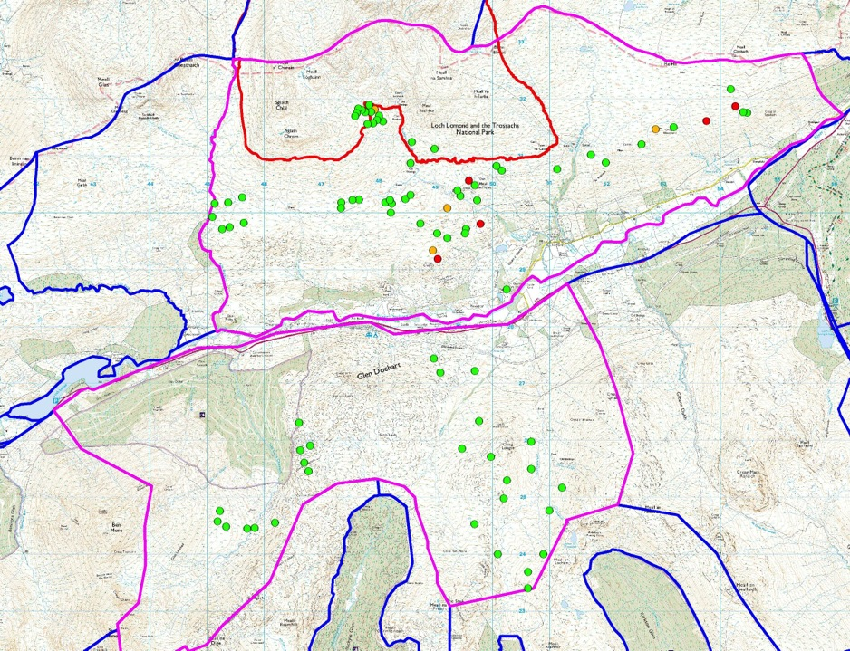
The levels of browsing within the site are overwhelmingly low, with only one plot falling outside the 'Low' impact class for blanket bog (It might be noted that blanket bog is generally less favoured by herbivores so it is normal for browsing impacts to be lower on this habitat).
Map 1. Browsing: all samples. Green dots: Low; Orange dots: Moderate; Red dots: High. Pink lines: estate boundary, red line SAC boundary, blue lines: adjacent estate boundaries.

The impacts on dwarf-shrub heath are only slightly higher however, with three Moderate and five High impacts recorded as the highest frequency browsing class within plots.

Table 4 - Trampling data – dwarf shrub heath

Trampling impact | Dwarf-shrub heath
Low-Moderate | 60
High | 0

For dwarf shrub heath the assessment of trampling impact is made from the presence or absence of broken stems and can only show whether samples are Low/Moderate (broken stems absent) or High (broken stems present). No plots recorded broken stems.

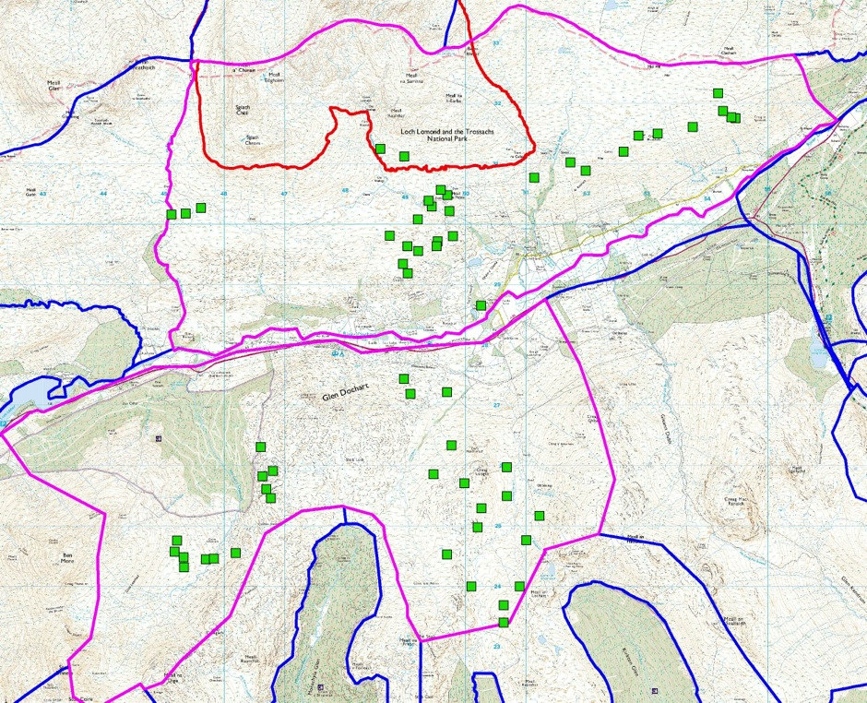
Map 2. Trampling: dwarf shrub heath. Green squares: Low.

Table 5 - Trampling data – blanket bog

Blanket bog: Trampling/prints in bare peat
 | Prints present | Prints absent
Number of Quadrats | 15 | 465
Percentage of Quadrats | 3 | 97
Blanket bog: Trampling/prints in Sphagnum

 | Prints present | Prints absent
Number of Quadrats | 33 | 447
Percentage of Quadrats | 7 | 93

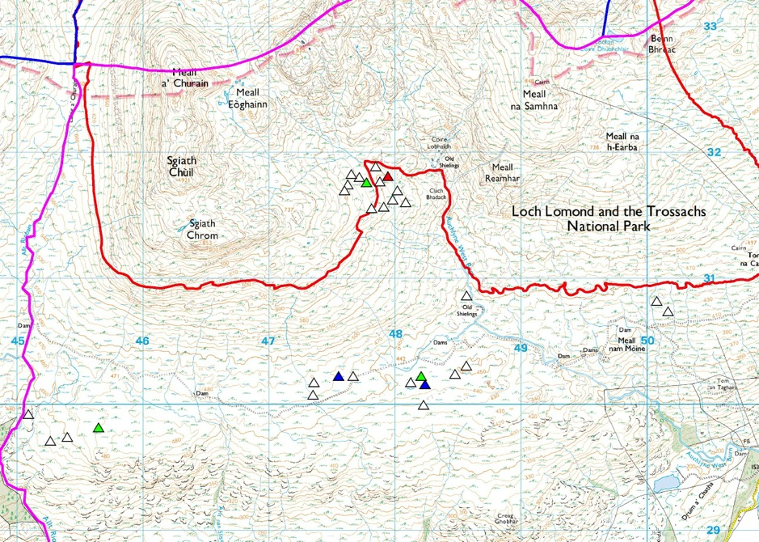
Map 3. Trampling: hoofprints in bare peat in blanket bog. Clear triangles: no prints, Green triangles: 1 print, Blue triangles: 3 prints, Red triangles: 6 prints

Within the blanket bog plots similarly low levels of trampling were discernible. Two types of indicator were used: hoof prints present in bare peat and hoof prints present in Sphagnum moss; the latter being a more sensitive indicator of deer traversing. Both indicators produced low impact levels with over 90% of quadrats recording absence of both types of hoof prints.

The vegetation was largely in good condition throughout the site with the average cover of heather within dwarf-shrub heath over 15/16 quadrats and over 10/16 quadrats with Sphagnum in the blanket bog plots. The average overall vegetation height for dwarf shrub plots was ca. 20 cm (ca. 16 cm for heather alone), and ca 19 cm (14.5 cm for heather alone) on blanket bog plots.

Deer dung was present in 32/60 dwarf-shrub heath plots and 12/30 blanket bog plots but rarely in large quantities. Sheep were frequently noted during the survey across the site but were commonest in Bovain and on the lower slopes of Auchlyne. Within Suie they were more scattered in lower areas and were mostly encountered concentrated around the richer grazing provided by open grassy areas developed over the Loch Tay Metalimestone band.

No signs of hare or cattle were noted in the vicinity of survey plots during the survey.

4. CONCLUSIONS

The results show low browsing impacts to be predominant on both dwarf-shrub heath and blanket bog. A few slightly higher impacts were recorded on dwarf-shrub heath, tending to occur mainly within Bovain and scattered on the lower slopes of Meall nam Moine and Creag Ghobar within Auchlyne.

The assessment of 'bog moss' cover within the blanket bog plots (average 10.3/16 quadrats) suggests that in general bare peat and other signs of trampling in blanket bog is comparatively limited (especially as significant numbers of the blanket bog plots comprised M19, which is often characterised by lower Sphagnum cover than M17). Accordingly trampling impact indicators were predominantly low throughout with just a few plots recording slightly elevated number of hoof prints scattered among the sample network. Trampling impacts on dry heath plots were uniformly low.

Signs of past burning within the site were limited and mainly confined to some areas of dwarf shrub heath in Suie. Where present it was not having a negative impact on the cover of heather within dwarf-shrub heath plots (average cover 15.7/16 quadrats). No signs of burns affecting deep peat areas (i.e. peat > 50cm) were noted, indicating good muirburn practice is being maintained helping to minimise impacts on the regeneration of bog moss.

The overall assessment is therefore of generally low impacts across the site. Bovain contained the most widespread areas of low dwarf shrub cover and more deer and sheep were noted in passing here than elsewhere on the site. However, impacts on dwarf shrubs were still predominantly low here and it is likely that the relative low heather cover may be primarily due to historical legacy of formerly much higher browsing impacts by sheep and deer.

The current impact levels suggest that herbivore levels within this site are appropriate for maintaining the moorland habitat in good condition, with little erosion even on steeper slopes.

REFERENCES

Bestpracticeguides.org.uk. (2018). Impacts | Best Practice Guidance. [online] Available at: https://www.bestpracticeguides.org.uk/impacts/ [Accessed 8 Aug. 2018].

Colquhoun, N (2016) Upland Habitat Impact Assessment Plan for Deer Management. Report for Innishewan Farms.

Rodwell J.S. 1991. British Plant Communities Vol. 2. Mires and Heaths. Cambridge University Press.

Rodwell J.S. 1992. British Plant Communities Vol. 3. Grasslands and Montane Communities. Cambridge University Press.

Stace C. 1997. New Flora of the British Isles (2nd edition). Cambridge University Press.

Appendices (SEE SEPARATE ATTACHED FILES)

APPENDIX 1: FIELD DATA
APPENDIX 2: MAPS
APPENDIX 3: RESULTS SUMMARIES
APPENDIX 4: PLOT PHOTOGRAPHS

